
home artists catalogue audio samples distribution contact
press cuttings press releases

artists

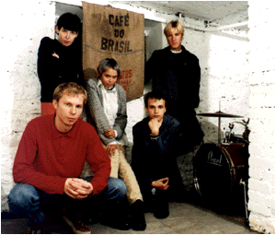
dallas
CD INFO PRESS CUTTINGS BIOGRAPHY DISCOGRAPHY MAIL ORDER AUDIO SAMPLES WWW LINKS
Five-piece group from Estonia making melodic, quirky pop songs. dallas compare their music to Stereolab, the Pastels, Velvet Underground, the Jesus & Mary Chain, Pulp, the Cardigans and Sonic Youth. Following the international release of their debut CD in early 1999, the group were Invited to play four concerts at Canadian Music Week in Toronto in March, four concerts at the North By Northeast festival in Toronto in June, and three concerts at the CMJ Music Marathon in New York in September. More international concerts soon.
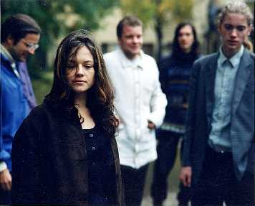
Lucius
CD INFO PRESS CUTTINGS BIOGRAPHY DISCOGRAPHY MAIL ORDER AUDIO SAMPLES WWW LINKS
The incredibly powerful voice of diminutive singer Karina Gretere fronts this five-person group from Latvia. The press has compared the Lucius sound to the Cocteau Twins, though the group use only acoustic instruments to perform their own intricate and carefully arranged songs. The first promo CD-single Little Barefeet was released in early 2000, to be followed by an album later in the year.


una bomba
CD INFO PRESS CUTTINGS BIOGRAPHY DISCOGRAPHY MAIL ORDER AUDIO SAMPLES WWW LINKS
Una Bomba [pronounced "oona bom-bar"] is a four-person noise machine from Estonia. In an earlier life, the group were invited to play at the New Music Seminar in New York City and recorded a music session for John Peel's BBC Radio One show in Great Britain. Then they changed their name, decided to wage war on the dancefloor, and performed for the ArtGenda Festival in Copenhagen and the Integration Party in Latvia. Debut CD released early 2000.

home artists catalogue audio samples distribution contact
press cuttings press releases
revised:3 feb 00

